|  |  |
| --- | --- |
| Data Privacy Policy Analysis Report : Google Privacy Policy | |
|  | |
| DATE: 8th October 2024INTERN : Cyber security | STUDENT NAME : Madhumitha.BCOMPANY NAME: Null Class |

|  |  |  |  |
| --- | --- | --- | --- |
|  |  |  |  |
|  | INTRODUCTIONThis report provides a comprehensive analysis of Google's Privacy Policy, evaluating its strengths and weaknesses based on several criteria: clarity, data collection, user rights, security measures, and legal compliance with major data protection laws like the General Data Protection Regulation (GDPR) and the California Consumer Privacy Act (CCPA).By examining these aspects, we aim to highlight effective privacy protections while identifying areas that need improvement. Finally, we will provide recommendations for enhancing Google's privacy practices. | |  |
|  | POLICY OVERVIEW | |  |
|  | .   * Google’s Privacy Policy outlineshow user data is collected, stored, and processed across its services such as Google Search, Gmail, YouTube, and others. * The policy aims to provide transparency about what personal data Google collects and why, and to explain users' rights regarding this data.      * As one of the largest data-driven companies in the world, Google holds vast amounts of information, making it essential that its policy protects users while maintaining compliance with privacy regulations. |  |  |

|  |  |  |  |
| --- | --- | --- | --- |
|  |  |  |  |
|  | Analysis **1. Clarity**  **Strengths:**   * **Transparency and Accessibility:** Google’s Privacy Policy is easy to locate and is provided in multiple languages. It is written in a conversational tone, which makes it more accessible to users without legal backgrounds. * **Visual Aids:** Google uses diagrams, examples, and links to related resources to clarify complex sections. The use of FAQs and summaries helps further simplify the content for the average user. * **Updates:** The policy is updated regularly, and users are notified of any significant changes via emails and notices on Google platforms.   **Weaknesses:**   * **Legal Jargon:** Despite its friendly tone, some parts still contain legal terminology that may be difficult for users to fully comprehend. * **Overly Broad Language:** In some sections, the language remains vague, especially concerning the specifics of how long user data is retained and exactly how it is shared with third parties.      * **Interpretation:** The bar chart shows that Google excels in transparency and notification of policy updates but could improve simplicity by reducing legal jargon. |  |  |

### Data Collection

**Strengths:**

* **Comprehensive Overview of Data Collected:** Google is transparent about the types of data it collects, including personal identifiers (name, email), browsing activity, device information, and location data.
* **Data Utilization Transparency:** Google provides clear explanations of why certain data is collected, such as for improving services, personalizing ads, and conducting research.

**Weaknesses:**

* **Excessive Data Collection:** Google's policy allows the collection of a wide range of data, some of which may not be strictly necessary for the stated purposes, raising concerns over data minimization.
* **Third-Party Sharing Ambiguity:** While Google states that data may be shared with third-party partners, it does not always specify who these partners are or provide sufficient detail about the extent of data sharing.



* **Interpretation:** The bar graph shows that Google collects a wide range of data types,

especially for advertising and service improvement purposes. Personal and activity data

are shared more often with third-party partners.

### User Rights

**Strengths:**

* **Right to Access and Portability:** Google allows users to access their personal data and download it through tools like Google Takeout. This promotes user control over their data.
* **Right to Delete Data:** Users can request the deletion of their account and personal data, fulfilling their right to be forgotten under GDPR. Google outlines step-by-step instructions for exercising this right.
* **Privacy Controls:** Google provides users with extensive control over privacy settings, allowing them to manage ad preferences, location tracking, and activity data collection.

**Weaknesses:**

* **Complex Procedures for Exercising Rights:** While user rights are provided, the process of exercising them (such as requesting data deletion or correction) can be time-consuming and complex, often involving multiple steps.
* **Limited Transparency on Data Retention:** The policy lacks clarity on how long data is retained after a user deactivates an account or requests deletion.

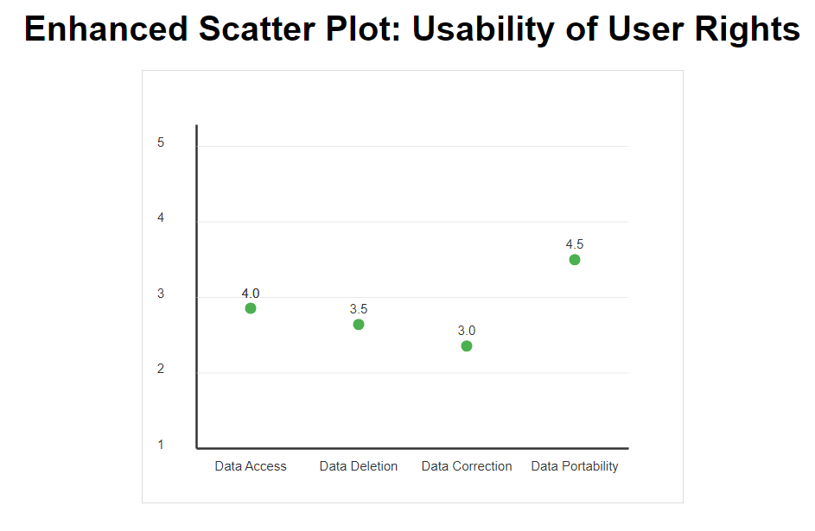

* **Interpretation:** Users can easily manage their privacy settings, but processes for data

deletion and correction can be cumbersome. Data portability is a well-established feature,

while correction options need improvement.

|  |  |
| --- | --- |
| Security measures **Strengths:**   * **Robust Security Framework:** Google employs advanced security technologies, including encryption (both at rest and in transit), two-factor authentication (2FA), and regular security audits, to safeguard user data. * **Incident Response:** Google provides details on how it handles data breaches, including user notification procedures in compliance with GDPR requirements.   **Weaknesses:**   * **Limited Information on Internal Access Controls:** While the policy discusses data protection from external threats, it does not provide sufficient detail about internal access controls, such as who within Google can access user data and under what conditions.      * **Interpretation:** The box plot shows that while Google excels in encryption and two-factor authentication, there are potential weaknesses in internal access controls, which need greater transparency. |  |
| **Strengths:**   * **GDPR Compliance:** Google complies with GDPR by allowing users to access, correct, and delete their personal data. It also provides clear consent mechanisms for data collection, particularly regarding cookies and personalized ads. * **CCPA Compliance:** Google adheres to the CCPA by offering California residents the right to opt out of data selling and providing disclosures on the categories of personal data collected.   **Weaknesses:**   * **Ambiguity Around ‘Data Selling’:** While Google states that it does not sell personal information, its broad data-sharing practices with advertising partners may blur the lines, raising questions about its compliance with the "do not sell" provisions of CCPA.  Compliance with Privacy Laws (GDPR, CCPA) |  |

* + Here I assess Google's compliance with **GDPR** and **CCPA** through different aspects like user consent, data access, and third-party sharing.

### Recommendations for Improvement

* **Enhance Clarity with Specifics:** While the policy is generally clear, it would benefit from avoiding vague language, especially around data sharing and retention periods. Google should provide more precise timelines and detailed explanations of third-party partnerships.
* **Implement Data Minimization:** Google should reconsider the amount of data it collects and adhere more strictly to the principle of data minimization, collecting only what is necessary for the service.
* **Simplify User Rights Processes:** Google should streamline the steps required to exercise user rights like data access, correction, and deletion, potentially by offering a single dashboard for managing these requests.
* **Increase Transparency in Third-Party Data Sharing:** Google should publish a detailed list of third-party entities with whom it shares user data, along with the purpose of each partnership, ensuring more user trust.
* **Clearer Data Retention Policies:** Google should be more transparent about its data retention practices, providing users with clearer information about how long their data is kept after service discontinuation.

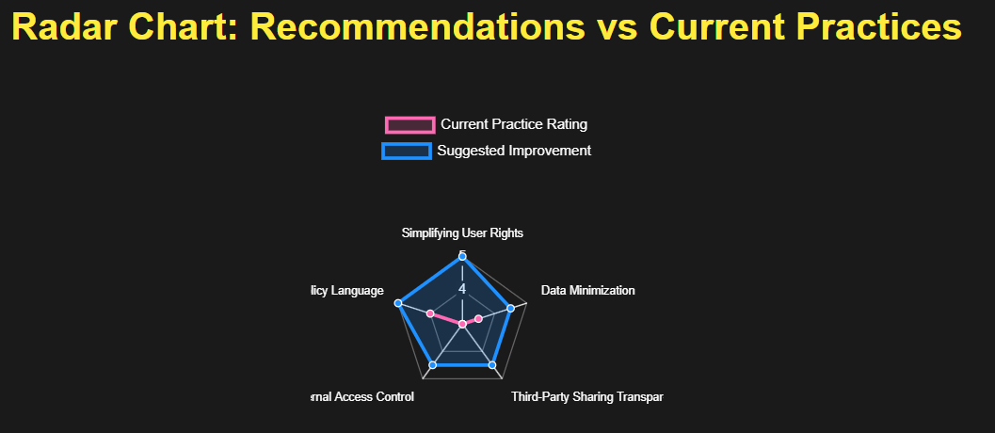

* **Interpretation:** The radar chart shows that improving user rights, third-party sharing transparency, and internal access controls will help Google’s privacy policy align with best practices.

### Strengths and Weaknesses

**Strengths:**

* **Transparency:** Google excels in transparency, offering a clear outline of what data is collected and why.
* **User Controls:** The platform provides users with a wide array of privacy controls, empowering them to manage their data settings.
* **Compliance:** Google demonstrates strong compliance with major data privacy regulations such as GDPR and CCPA.
* **Security:** The company employs advanced security mechanisms to protect user data, including encryption and multi-factor authentication.

**Weaknesses:**

* **Overly Broad Data Collection:** The policy could benefit from more stringent data minimization principles to avoid collecting excessive user information.
* **Third-Party Sharing Transparency:** More explicit details on third-party data sharing, including a list of partners, would strengthen the policy.
* **Data Retention Ambiguity:** Clearer timelines on how long data is retained, particularly after account deletion, should be provided.
* **Complex Processes for User Rights:** Streamlining the process for exercising user rights could make it easier for individuals to manage their personal data effectively.

### Conclusion

* This analysis of Google's Privacy Policy shows that the company provides strong security, user control, and compliance with major privacy laws. However, areas like third-party data sharing, complex user rights processes, and overly broad data collection practices can be improved. Implementing the recommendations and adopting clearer practices would further enhance privacy protection for users.
* By integrating these visualizations, the analysis becomes more intuitive, offering clearer insights into the policy’s effectiveness and areas for improvement.

### Reference

* *Google Privacy Policy*. Last updated: April 4, 2023. Available at: <https://policies.google.com/privacy>
* *Google’s GDPR Compliance Measures*. Available at: <https://iapp.org/news/a/understanding-googles-gdpr-compliance/>
* *How Google Collects Your Data: Analysis of Google’s Data Collection Practices*. Available at: <https://www.privacytools.io/articles/how-google-collects-your-data/>
* *Google's CCPA Compliance FAQs*. Available at: <https://privacy.google.com/businesses/ccpa/>